
Installing a Suite B Only PKI
Microsoft Corporation
Published: March 2009
Authors:
Larry Talbot
Contributors:
Henry Jerez Morales
Vishal Agarwal
Nick Voicu

Abstract
This white paper discusses the planning and implementation of a Microsoft® Windows Server® 2008 and Windows Server® 2008 R2 public key infrastructure (PKI) that utilizes fully Suite B compliant cryptographic algorithms. It describes behavioral differences between the two platforms, identifies what is supported and what is recommended, and provides step-by-step instructions for the most common tasks. It also offers high-level guidance on how to create a deployment plan specific to your environment. All mentions of Windows Server 2008 R2 refer to pre-release versions and behaviors associated with these versions are subject to change within the release version.

Copyright Information
This document is provided for informational purposes only and Microsoft makes no warranties, either express or implied, in this document. Information in this document, including URL and other Internet Web site references, is subject to change without notice. The entire risk of the use or the results from the use of this document remains with the user. Unless otherwise noted, the example companies, organizations, products, domain names, e-mail addresses, logos, people, places, and events depicted herein are fictitious, and no association with any real company, organization, product, domain name, e-mail address, logo, person, place, or event is intended or should be inferred. Complying with all applicable copyright laws is the responsibility of the user. Without limiting the rights under copyright, no part of this document may be reproduced, stored in or introduced into a retrieval system, or transmitted in any form or by any means (electronic, mechanical, photocopying, recording, or otherwise), or for any purpose, without the express written permission of Microsoft Corporation.

Microsoft may have patents, patent applications, trademarks, copyrights, or other intellectual property rights covering subject matter in this document. Except as expressly provided in any written license agreement from Microsoft, the furnishing of this document does not give you any license to these patents, trademarks, copyrights, or other intellectual property.

© 2008 Microsoft Corporation. All rights reserved.

Active Directory, Microsoft, Windows, Windows Server, and Windows Vista are trademarks of the Microsoft group of companies.

All other trademarks are property of their respective owners.

Contents
Introduction 4
Suite B in Windows Server 2008 4
1. Pre-Installation CA Configuration 5
2. Installing the Certificate Authority 6
3. Preparing the CA for Key Archival 7
Configuring the CA Encryption Settings 7
Configuring the CA Exchange Certificate Template 8
Configuring the Key Recovery Agent (KRA) Certificate 12
4. Certificate Template Configuration 15
Configuring Encryption Templates for Key Archival 15
Suite B in Windows Server 2008 R2 16
1. CA Setup and Configuration 17
Pre- Installation 17
Post Installation 17
2. Certificate Templates 18
Appendix A: Suite B and IPSec 18
Configuring Suite B IPSec on Windows Server 2008 18
Configuring Suite B IPSec Template 18
Configuring IPSec Rules 23
Suite B IPSec and Windows Server 2008 R2 25
Appendix B: Troubleshooting 26
Unable to subordinate a Suite B CA under an enterprise CA when using a version 2 or version 3 Sub CA template. 26

Introduction
Suite B is a set of cryptographic algorithms that was defined by the NSA as part of an effort to modernize information assurance capabilities. It is intended to cover both unclassified information as well as most classified information. For more information about the NSA’s Suite B specifications, please see http://www.nsa.gov/ia/programs/suiteb_cryptography/index.shtml.
Suite B includes the following cryptographic algorithms and key/curve sizes for encryption, digital signatures, key exchange, and hashing:
Algorithm | Secret | Top Secret
Encryption:  Advanced Standard (AES) | 128 bits | 256 bits
Digital Signature:  Elliptic Curve Digital Signature Algorithm (ECDSA) | 256 bit curve. | 384 bit curve
Key Exchange:  Elliptic Curve Diffie-Hellman (ECDH) | 256 bit curve. | 384 bit curve
Hashing:  Secure Hash Algorithm (SHA) | SHA-256 | SHA-384
Support for these new algorithms was first introduced in Windows Vista® and the ability to implement them in a PKI deployment with Windows Server 2008. This document will detail and discuss the specific steps needed to deploy a Suite B only PKI in both Windows Server 2008 and Windows Server 2008 R2 environments. This document will also detail the gaps between the two platforms and highlight the improvements that within Windows Server 2008 R2.
This document is intended to provide step-by-step instructions and guidance on how to install and configure a Microsoft PKI in a test environment that utilizes only Suite B algorithms. In addition to detailing the set up of the PKI, certain areas of attention that may be required for common deployment scenarios will be identified.

Suite B in Windows Server 2008
As noted, Windows Server 2008 was the first version of Windows Server capable of incorporating Suite B capability into a PKI deployment. With Windows Server 2008, a Certificate Authority (CA) is installed through the installation of the Active Directory Certificate Services role. When installing a Windows Server 2008 CA, Suite B algorithma (ECDSA_P256 or ECDSA_P384) can be selected for the CA’s signing certificate. In addition to the CA’s signing key being Suite B compliant, a pure Suite B PKI would also need to issue end entity certificates that are also Suite B compliant. With a Windows Server 2008 Active Directory schema, support for version 3 certificate templates is introduced. Only version 3 certificate templates support Suite B algorithms.
Note
Version 3 templates can only be issued by an enterprise CA installed on computers running Windows Server 2008 Enterprise and Windows Server 2008 Datacenter Editions or Windows Server 2008 R2. Issued certificates based upon version 3 templates can only be used by clients that are Windows Vista or later. For more information on certificate templates, please see the “Implementing and Administering Certificate Templates in Windows Server 2008” whitepaper at http://technet.microsoft.com/en-us/library/cc731256.aspx.
The following sections will detail the specific steps necessary to implement a fully Suite B compliant PKI within a Windows Server 2008 infrastructure. This document will work under the assumption that this is a new deployment and that no previous PKI exists. In any PKI deployment, it is recommended that all current best practices and guidelines are followed. For more information about planning and deploying Active Directory Certificate Services, please see http://technet.microsoft.com/en-us/library/cc534992.aspx.

Pre-Installation CA Configuration
The first step in deploying a Windows PKI is installing the CA. An enterprise CA is recommended as the type of CA to be used for issuing end entity certificates, due to its interaction with the Active Directory (AD) and the value and benefits provided with this interaction. One of the key behavioral features of an enterprise CA is that all certificates issued by it are based upon certificate templates that reside within the Configuration container in the AD. The certificate templates contain information and details about what should be included within issued certificates and also on factors affecting key creation. A base set of certificate templates and other related PKI objects and containers get added to the AD upon the installation of the first CA within the enterprise.
When an enterprise CA in installed, by default it will be pre-configured with a set of commonly used certificate templates. However, none of the default certificate templates are preconfigured to utilize or leverage Suite B algorithms. In order to avoid the inadvertent enrollment of any certificates that do not conform to Suite B standards, from a newly installed CA, the installation must be modified such that the default templates will not be loaded. To do this, a CAPolicy.inf file will need to be created within the %SystemRoot% directory prior to the CA is installation. If a CAPolicy.inf file exists, the settings defined within it will supersede the default configuration that is used to install a CA or renew its CA certificate. For more information on how to configure a CAPolicy.inf file, please see http://technet.microsoft.com/en-us/library/cc756120.aspx. The following sample lines included in a CAPolicy.inf file will suppress the default templates on the CA:
[Version]
Signature= "$Windows NT$"
[Certsrv_Server]
LoadDefaultTemplates = False
Once the CAPolicy.inf file is saved in the %SystemRoot% directory, the CA installation can begin.

Installing the Certificate Authority
To install a CA in Windows Server 2008, the Active Directory Certificate Services role must be added to the server. All server roles are managed through the Server Manager console and the installation will begin there.
CA Installation Steps:
  - Log on as an Enterprise Administrator.
  - In Administrative Tools, open Server Manager.
  - In the console tree, click Roles.
  - In the details pane, click Add Role. The Add Roles Wizard will then start. Click Next in the welcome page.
  - In the Select Server Roles page, select Active Directory Certificate Services and click Next.
  - Click Next in the Introduction to Active Directory Certificate Services page.
  - In the Select Role Services page, select Certificate Authority and click Next.
  - In the Specify Setup page, select Enterprise and click Next.
  - In the Specify CA Type page, select Root CA and click Next.
Note
In a production deployment, it is generally recommended that a root CA is an offline, stand-alone, rather than an enterprise. Additionally, root CAs are not typically used for the issuance of end entity certificates. The use of an enterprise root in this case is purely for example purposes and this model is not recommended in production deployment scenarios.
  - In the Set Up Private Key page, select Create a new private key and click Next.
  - In the Configure Cryptography for CA page, select the following options then click Next:
  - For CSP, select ECDSA_P256#Microsoft Software Key Service Provider
  - For Key Character Length, select 256
  - For the hash algorithm, select SHA256
Note
For Suite B compliance, the ECDSA_P384#Microsoft Software Key Service Provider as well as the 384 key size and SHA384 as the hash algorithm may also be selected if the level of classification desired is Top Secret. The settings that correspond with the required level of classification should be used. ECDSA_P521 is also available as an option. While the use of a 521 bit ECC curve may exceed the cryptographic requirements of Suite B, due to the non-standard key size, 521 is not part of the official Suite B specification.
  - In the Configure CA Name page, enter a desired common name. The distinguished name suffix will default to that of domain the CA server is a member of. This field may be edited if desired. When completed, click Next.
  - In the Set Validity Period page, set the desired validity period and click Next.
  - In the Configure Certificate Database page, the default locations for the CA database and log files can be accepted or alternate locations may be defined. When complete, click Next.
  - The following page will confirm all the installation configuration settings selected to this point. If all the settings are correct, click Install to begin the CA installation process.
At this point, the CA installation should continue without further interaction. When the installation has completed, a dialog indicating the installation results is displayed.

Preparing the CA for Key Archival
The CA is now installed and using an ECDSA signing key but is not yet configured to issue any certificate templates. It is capable of issuing certificates that are also Suite B compliant and that may be used in a variety of situations. Included are encryption certificates, for which key archival and recovery may be desired. Before the CA begins issuing these certificates and performing key archival, it is necessary to ensure that these activities are also operating within a Suite B compliant manner.
There are three items that need attention in order to for the CA to be able to support key archival in a Suite B compliant manner:
- Configure the CAs encryption settings
- Configure the CA Exchange certificate template
- Configure the Key Recovery Agent (KRA) certificate template

Configuring the CA Encryption Settings
In performing private key archival, a Windows Server 2008 CA uses encryption to ensure security of the private key material during both the transportation from the client and the storage within the CA database. Even though a Suite B signing key was selected during the CA installation, Windows Server 2008 does not default to the use of Suite B encryption algorithms for key archival. In order to maintain a strict Suite B environment, the default configuration around the CA’s encryption keys must be edited.
There are four specific items that must be edited:
- The encryption algorithm
- The symmetric key size
- The public key algorithm
- The public key size
For more information on key archival and what each of these specific setting mean, please see the “Active Directory Certificate Services Longhorn Beta3 Key Archival and Recovery Whitepaper “.
To configure these items for Suite B compliance, run the following commands in an elevated Command Prompt on the CA server:
Certutil –setreg ca\EncryptionCSP\CNGEncryptionAlgorithm AES
Certutil –setreg ca\EncryptionCSP\SymetricKeySize 128
Certutil –setreg ca\EncryptionCSP\CNGPublicKeyAlorithm ECDH_P256
Certutil –setreg ca\EncryptionCSP\KeySize 256
- Note
Again, the key sizes selected above may be adjusted according to the level of classification required. The AES symmetric key may also be 256 bit and the public key algorithm may be ECDH_P384.
In order for these changes to be effective, the CA service must be stopped and re-started.

Configuring the CA Exchange Certificate Template
The CA Exchange certificate is used by enrollment clients to encrypt their private key material for transport to the CA. With the above changes, the CA will be able to issue a CA Exchange certificate that utilizes an ECDH public key. One additional change is required, however, in order for strict Suite B compliance. When the CA issues a CA Exchange certificate, it uses certain parameters that are defined within the CA Exchange certificate template. Due to the fact that none of the default templates are configured for Suite B compliance, the CA Exchange template must be edited in order to provide this compliance. By default, the CA Exchange template has the Key Usage extension set for key encipherment. Key Encipherment is an RSA feature and is not Suite B compliant. Instead, this setting should be changed to key agreement.
- Note
The CA Exchange template does not need to be explicitly configured on the CA in order to be utilized. Additionally, certain configuration settings, such as those made regarding the CA encryption keys, will override the settings defined within the template. The edits made to this specific template will not necessarily be consistent with those made for other Suite B enabled certificate templates.
To edit the CA Exchange template, either Server Manager or the stand alone Certificate Templates snap-in can be used. The stand alone snap-in can be launched by running certtmpl.msc. The steps for editing the CA Exchange template using Server Manager are:
  - Within the Server Manager Console tree, navigate down into Active Directory Certificate Services and select Certificate Templates.
  - In the details pane, double click the CA Exchange template.
  - In the template dialog, select the Extensions tab. On the Extensions tab, select Key Usage and click Edit.
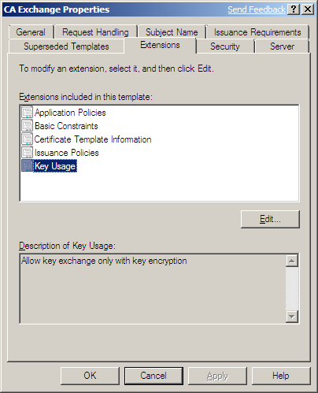
  - In the Edit Key Usage Extension dialog, select the option to “Allow key exchange without key encryption (key agreement). Selecting to mark the extension as critical is also an option, although this is not required. When completed, click OK and OK again in the following window.
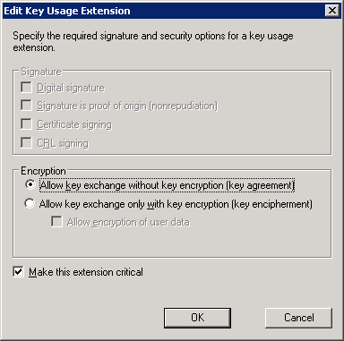

  - Note
Making this edit will affect all CA Exchange certificates issued and used by all enterprise CAs within the forest. In a pure Suite B environment, this will not be a problem. However, even if other non-Suite B CAs exist that may also utilize this template, having the Key Usage extension set to key agreement, rather than key encipherment, should not have any adverse affects.
With the template modified, the CA can now issue a Suite B compatible CA Exchange certificate. While not necessary, the CA can be manually triggered to issue a CA exchange certificate, if it has not yet done so, by running;
Certutil –cainfo xchg
To view the newly issued CA Exchange certificate, use either Server Manager or the stand alone Certificate Authority console by running certsrv.msc.
To manage the CA using the Server Manager console, in the left hand pane, expand Roles, Active Directory Certificate Services, and the CA. In the CA tree, select Issued Certificates. In the details pane, double click the newly issued CA Exchange certificate to view its properties.
On the Details tab, notice the values for the Public key parameters and Key Usage extensions…
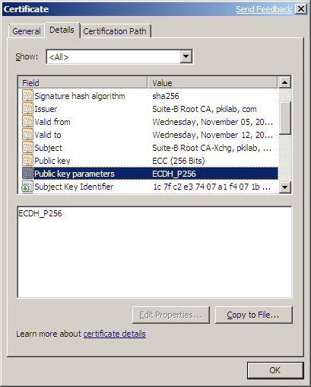

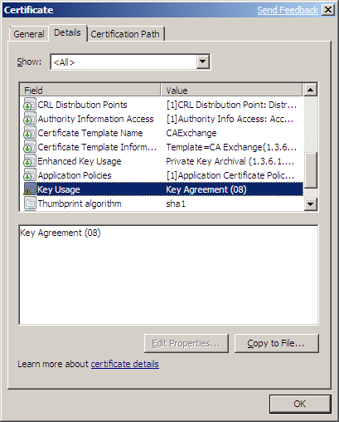

The Public key parameters should match those defined for the CNGPublicKeyAlgorithm and KeySize within the CA encryption properties and the Key Usage extension should be set to Key Agreement.

Configuring the Key Recovery Agent (KRA) Certificate
To this point, the steps to edit the CA configuration and the CA Exchange template in order for the CA to be Suite B compatible for key archival operations have been detailed. One additional step in enabling key archival is defining a KRA certificate. A default KRA certificate template is provided for this purpose; however, again, the default certificate templates do not provide Suite B support. As previously mentioned, support for Suite B is available only in version 3 templates. To enable a Suite B KRA certificate, a new version 3 template must be created. The easiest way to do this is to select the existing default KRA template and duplicate it. This will create a new template object which can then be edited and modifed as desired.
The steps for creating a new KRA template using Server Manager are:
- In the Server Manager Console tree, expand Roles then Active Directory Certificate Services. Select Certificate Templates.
- In the details pane, select the Key Recovery Agent template. To duplicate this template, right click and select Duplicate Template. Select the option to create a Windows Server 2008, Enterprise Edition version template and click OK.
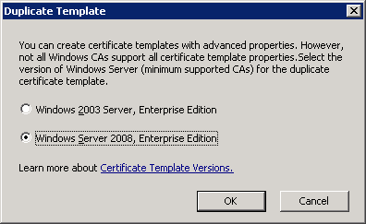
- On the General tab, define a name for the new template and define the validity and renewal periods as desired.
- On the Cryptography tab, define the algorithm and key size to be used when requesting this certificate. Select ECDH_P256 for the Algorithm name and 256 for the Minimum key size. Also, select SHA256 as the Hash algorithm. Again, the 384 options may also be selected if desired.

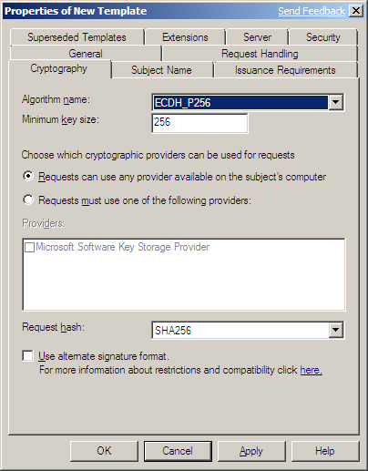
Although, it is not necessary, a specific cryptographic provider may be defined. If this option is selected, from any installed provider that supports the chosen algorithm and key size may also be selected.
- On the Extensions tab, as with the CA Exchange template, for the Key Usage extension, select the option to “Allow key exchange without key encryption (key agreement). This extension can also be marked as critical, although this is not required. When completed, click OK and OK again in the following window.
A new version 3 KRA template has been created that is configured to utilize Suite B compliant algorithms. In order for the CA to be able to perform archival, a new KRA certificate must be issued, using this new template, and defined on the CA. For instructions and best practices on how to configure recovery agents please see the “Active Directory Certificate Services Longhorn Beta3 Key Archival and Recovery Whitepaper “.
- Note
To this point, no certificate templates have been added to the CA. Since a CAPolicy.inf was utilized in order to suppress the loading of the default templates, a null object will be displayed within the CA template configuration. This object may be safely deleted.

Certificate Template Configuration
With the CA being completely configured to operate in a Suite B only mode, any templates intended to be used for certificate issuance must also be appropriately configured. The last section detailed the steps to edit the CA configuration and the CA Exchange and KRA templates in order for the CA to be Suite B compatible for key archival operations. In order for a PKI deployment to be fully Suite B compliant, all certificates issued by the CA must also be Suite B compliant. This includes any encryption certificates and keys that are intend to be archived. The following section will detail the steps necessary to create a Suite B compliant encryption template that is configured for key archival.

Configuring Encryption Templates for Key Archival
As previously noted, certificate templates can be managed using either Server Manager or the stand alone Certificate Templates snap-in. Again, none of the default templates provide Suite B compatibility, so in order to configure a template for Suite B use; a new template must be created.
- Repeat steps 1-5 from the Configuring the KRA Certificate example above, only selecting any other encryption template instead of the KRA template, such as “Basic EFS”.
- Next, go the Request Handling tab. In this dialog, select the option to “Archive subject’s encryption private key”, then select the option to “Use advanced Symmetric algorithm to send key to the CA”. With this option selected, the client will use AES-256 to encrypt the private key material for transport to the CA; otherwise, 3DES will be used. In order for the archival process to be successful ensure that the “Allow private key to be exported” option is selected.

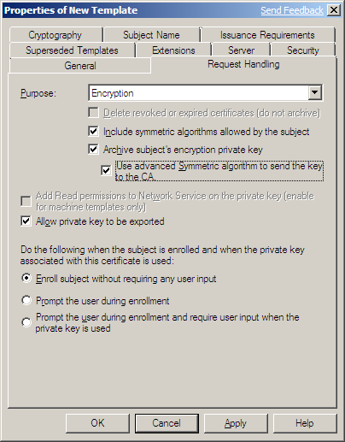

- On the Extensions tab, edit the Application Policies as desired in order for the issued certificates to be valid for their intended purpose. For example, if this certificate is to be used for EFS encryption, ensure the Encrypting File System application policy is enabled. In the event S/MIME encryption is desired, ensure Secure Email application policy is enabled.
- Edit configuration setting on other tabs as desired. When complete, select OK to save the changes
In order for clients to obtain certificates based upon this newly created template, it must be added to the CA configuration. Certificate issuance and specific enrollment instructions will not be detailed within this document. All normal enrollment options are still available, including auto enrollment.

Suite B in Windows Server 2008 R2
The PKI deployment process in a Windows Server 2008 R2 environment is essentially the same as that in a Windows Server 2008. With Windows Server 2008 R2, some key improvements around Suite B support in Certificate Services have been made. With regard to Suite B, they main difference between the two platforms is the ease in which the PKI is deployed and the additional Suite B application support provided with Windows Server 2008 R2. While configuring a Suite B only PKI in Windows Server 2008 was possible, changes have been made in Windows Server 2008 R2 in an attempt to reduce the effort and complexity of the deployment and improve the overall user experience. The remaining sections, will focus strictly on features and differences of the Suite B PKI deployment process, without going into detail about application and service support of Suite B within Windows Server 2008 R2.

CA Setup and Configuration
The actual CA installation process between the two systems is essentially identical. In both cases, the CA is installed as part of the Active Directory Certificate Services role and its installation is performed via Server Manager and the Add Roles wizard. The key differences are the actions that needed to be taken both before and after the CA installation in Windows Server 2008 are no longer necessary in Windows Server 2008 R2. These differences are as follows:

Pre- Installation
The key difference to note here is with regard to the loading of default certificate templates. When installing a Windows Server 2008 R2 CA and a Suite B signing key is selected during setup, no certificate templates are loaded by default. This means there is no need to create a CAPolicy.inf file prior to the CA installation in order to ensure that non-Suite B template are not defined on the CA and that no non-Suite B compliant certificates will be issued by the CA inadvertently.

Post Installation
Another key difference between the two systems is with regard to the CA encryption settings. In Windows Server 2008 these settings were configured by default, without regard to the CA signing key algorithm selected and used during setup. This required us to make configuration changes after the initial CA installation in order to ensure these settings were also Suite B compliant. With Windows Server 2008 R2, these settings are now configured by default, depending upon what key algorithms are chosen during CA setup. If an ECDSA signing key is created during CA installation, then the CA will be configured with default Suite B encryption settings based upon the algorithm and key size used.
For example, if the CA is installed using an ECDSA_P256 key, then the default encryption settings will include the ECDH_P256 algorithm, as well as AES for encryption with a 128 bit key. If the CA is installed using ECDSA_P384, the default encryption settings will include the ECDH_P384 algorithm and AES with a 256 bit key. Any CA Exchange certificate issued by the CA will utilize an ECDH key that corresponds in size to the CA’s ECDSA signing key. Additionally, it is no longer necessary to manually edit the CA Exchange certificate template to enable the key agreement key usage. The key usage within issued CA Exchange certificates will be correctly set to key agreement by default, when an ECDH key is used.

Certificate Templates
There is little change in Windows Server 2008 R2, with regard to how certificate templates are created, configured or assigned on the CA. All these actions are performed in essentially the same way as they would be performed in a Windows Server 2008 environment.
The one difference that is present is in defining the Key Usage extension. Similar to the CA Exchange certificate case, when the key purpose is defined as Encryption, and an ECC algorithm is selected, the Key Usage extension will automatically be set to Key Agreement, eliminating the need to manually edit the key usage extension as was necessary with Windows Server 2008. This is true for any version 3 template that is created from a Windows Server 2008 R2 system.

Deployment Considerations
Regardless of whether the Suite B CA is installed on Windows Server 2008 or on Windows Server 2008 R2, the same overall deployment considerations should be noted. Specifically, these include maintaining strict Suite B compliance across all certificates issued as well client and application compatibility.

Certificate Templates
As previously noted, none of the default templates provided are configured for Suite B support. With this in mind, if the desire is to maintain a pure Suite B environment, ensure that all certificates issued by the CA are properly configured for Suite B compliance. In order to do this, create a new template for each type of certificate that is intended to be issued. Some common certificate types that are widely used in many enterprise PKI deployments include:
- Domain Controller certificates
  - Domain Controller Authentication
  - Directory Email Replication
  - Kerberos Authentication
- Client Authentication certificates
  - Smartcard User/Smartcard Logon
  - User
  - Workstation Authentication
- Server Authentication certificates
  - Computer
  - Web Server
  - RAS and IAS Server
- Secure Email (S/MIME) certificates
  - Exchange User (encryption)
  - Exchange Signature Only
- Encryption certificates
  - Basic EFS
- IPSec Certificates
- Code Signing certificates
- OCSP Response Signing certificates
- Enrollment Agent certificates

Client and Application Support
Before deployment of any PKI that may involve the use of Suite B algorithms, it is recommended to ensure all client and server systems that may interact with this PKI support these algorithms. For Windows systems, this requires that all clients systems be Windows Vista or above and that all servers systems are Windows Server 2008 and above. Down level client and server systems will not be able to consume nor use certificates that utilize Suite B algorithms.
In addition to the systems themselves, there may be applications that have compatibility issues with Suite B support. Before deploying a Suite B PKI, ensure that all applications or services which are intended to interact with or use any certificates, will support the Suite B algorithms that will be used.

Appendix A: Suite B and IPSec
Support for Suite B cryptographic algorithm use with IPSec was first added in Windows Vista Service Pack 1 (SP1) and in Windows Server 2008. The following section will step through a deployment example, detailing how to configure IPSec to work with Suite B and use the certificates authentication.
The goal of this document is not to provide specific IPSec installation and configuration steps, but rather to detail an example of a Suite B compatible technology that utilizes a Suite B PKI. For more information about IPSec and Suite B compatibility, please see http://support.microsoft.com/kb/949856/en-us.

Configuring Suite B IPSec on Windows Server 2008
Before an IPSec security connection rule is authored and enabled, ensure all participating machines have enrolled for a Suite B compatible IPSec certificate. This certificate must reside within the machine’s personal certificate store. If manual enrollment is used to obtain this certificate, the user performing the enrollment must have Administrator rights on the system.

Configuring Suite B IPSec Template
The following example will detail the steps necessary to create a Suite B certificate template that will be used for the issuance of IPSec authentication certificates. These certificates will be implemented within a sample Suite B IPSec policy, configured later in this document.
- In the Server Manager console tree, expand Roles then Active Directory Certificate Services. Select Certificate Templates.
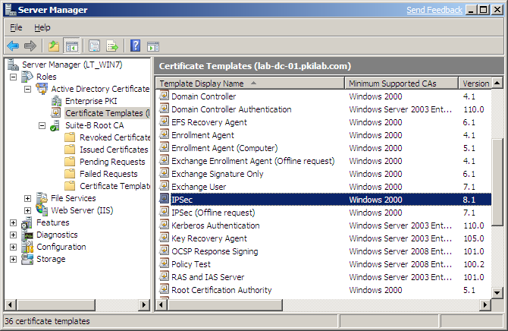

- In the details pane, select the default IPSec template. To duplicate this template, right click and select Duplicate Template. Select the option to create a Windows Server 2008 version template and click OK.

- On the General tab, define a name for the new template and define the validity and renewal periods as desired.

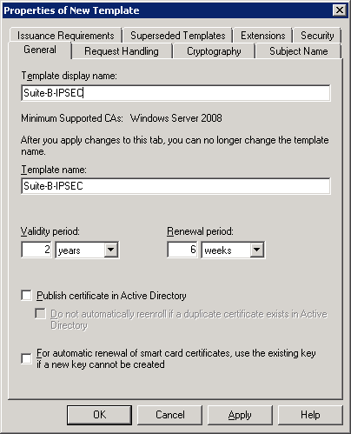

- Next, go the Request Handling tab. In this dialog, define the key Purpose, which will identify how the key is intended to be used.
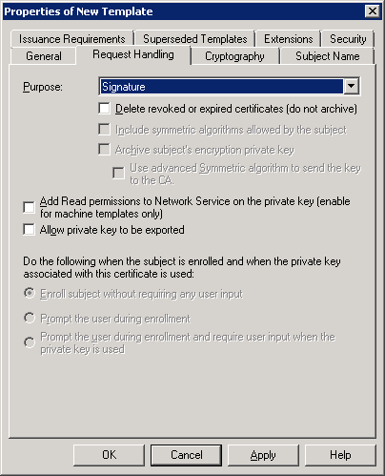

For an IPSec certificate, select Signature for the purpose. When the purpose is changed, a dialog will appear, notifying you of the effects of changing this setting and prompting you to confirm the change. Click Yes.

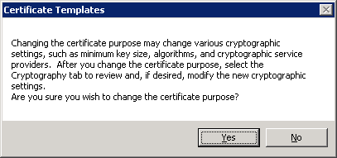

  - Note
With Suite B, the ECC key for a given certificate can only be used for either signature or encryption, but not both. Be sure not to select the option for both Signature and Encryption. If both signature and encryption are selected, then only ECDH algorithms will be available and the key will only be valid for encryption.
- On the Cryptography tab, define the algorithm and key size to be used when requesting this certificate. Select ECDSA_P256 for the Algorithm name and 256 for the Minimum key size. Also, select SHA256 as the Hash algorithm. Again, the ECDSA_P256 and SHA384 may also be selected if desired.

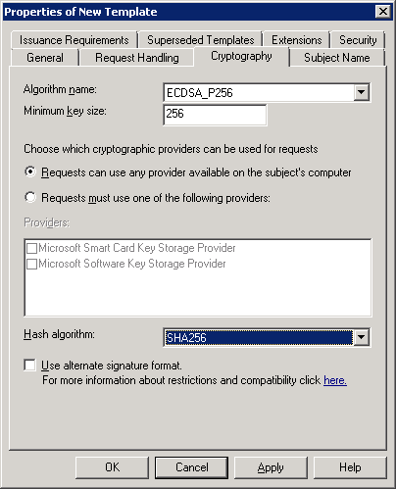

- On the Extensions tab, select Key Usage and click Edit. In the dialog, ensure Digital signature is checked. Additionally, the extension may be marked as critical, but it is not required. When complete, click OK.

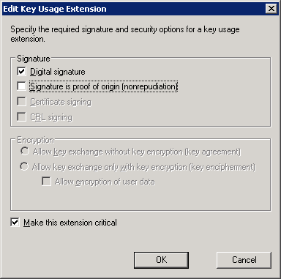

- Edit the template enrollment permissions on the Security tab and define any Issuance Requirements or Subject configuration for the template if desired. When the template configuration is complete, click OK.
A certificate template that can be used to issue Suite B compliant IPSec authentication is now available. In order to issue these certificates, the template needs to be added to the CA.

Configuring IPSec Rules
Once all participating systems have the required certificate, add the rule on each machine. The authoring of policies that contain Suite B algorithms is not supported in the "Windows Firewall with Advanced Security" console on Windows Server 2008. All policy authoring and editing must be performed using the netsh advfirewall command.
To create the new security connection rule, on each participating machine run the following command:
netsh advfirewall consec add rule name=Client endpoint1=any endpoint2=any action=requestinrequestout auth1=computercertecdsap256 auth1ecdsap256ca="DC=com, DC=pkilab, CN=Suite-B Root CA" qmsecmethods=ah:aesgmac256+esp:aesgcm256-aesgcm256
This command will create a new rule named Client, that will apply to any source or destination IP. The system will request IPSec negotiation, but if unable to do so, will fall back to clear. The rule defines a single authentication method which requires and ECDSA-P256 signing certificate issued by the “Suite-B Root CA”. The connection security rule also protects traffic by using AH and ESP integrity with the new AES-GMAC 256 algorithm and with AES-GCM256 for encryption.
In addition to the connection security rule settings, the global Main-mode settings must also be defined. On each participating machine, run the following command to define global Main-mode settings:
netsh advfirewall set global mainmode mmsecmethods ecdhp256:aes256-sha256
This command uses ECDH-P256 for key exchange, AES-256 for encryption and SHA256 for integrity.
An additional detail around IPSec and Windows Server 2008, is the introduction of Authenticated IP (AuthIP). AuthIP is enabled by default in Windows Server 2008. However, AuthIP does not support the use of Diffie Hellman (DH) for key exchange and therefore, does not support ECDH. In order to operate a Suite B IPSec implementation, Auth IP must first be disabled. This is done through a registry edit.
The following DWORD value must be added to every machine that will be participating in the IPSec implementation.
HKEY_Local_Machine\SYSTEM\CurrentControlSet\Services\IKEEXT\Parameters
IKEFlags = 0x00000040 (64)

To verify the connection rule settings, run the following command:
C:\Windows\System32>netsh advfirewall consec show rule all

Rule Name: Client
----------------------------------------------------------------------
Enabled: Yes
Profiles: Domain,Private,Public
Type: Static
Mode: Transport
Endpoint1: Any
Endpoint2: Any
Protocol: Any
Action: RequestInRequestOut
Auth1: ComputerCertECDSAP256
Auth1ECDSAP256CAName: DC=com, DC=pkilab, CN=Suite-B Root CA
Auth1ECDSAP256CertMapping: No
Auth1ECDSAP256ExcludeCAName: No
Auth1ECDSAP256CertType: Root
Auth1ECDSAP256HealthCert: No
MainModeSecMethods: ECDHP256-AES256-SHA256
QuickModeSecMethods: AH:AESGMAC256+ESP:AESGCM256-AESGCM256+60min+100000kb
Ok.
To view/verify any security associations (SA), both Quick-mode and Main-mode, run the following commands:
C:\Windows\System32>netsh advfirewall monitor show qmsa

Quick Mode SA at ?11/?07/?2008 16:57:44
----------------------------------------------------------------------
Local IP Address: 10.10.10.1
Remote IP Address: 10.10.10.2
Local Port: Any
Remote Port: Any
Protocol: Any
Direction: Both
QM Offer: AH:AESGMAC256+ESP:AESGCM256-AESGCM256+60min+100000kb
PFS: None
Ok.

C:\Windows\System32>netsh advfirewall monitor show mmsa

Main Mode SA at ?11/?07/?2008 17:02:48
----------------------------------------------------------------------
Local IP Address: 10.10.10.1
Remote IP Address: 10.10.10.2
Auth1: ComputerCertECDSAP256
Auth2: None
MM Offer: ECDHP256-AES256-SHA256
Cookie Pair: e364047f66d0547f:648b3fe83f6cb483
Health Cert: No
Ok.

Suite B IPSec and Windows Server 2008 R2
Suite B support with IPSec was initially provided with Windows Server 2008. The previous section discussed a couple of limitations and usability issues around its implementation. Windows Server 2008 R2 has improved the Suite B IPSec experience in a couple of key areas.
- IPSec Policy and Security Connection Rules
Another limiting aspect of a Suite B IPSec implementation on Windows Server 2008 was the fact that the authoring or security connection rules was not supported in the Windows Firewall with Advanced Security management console. All connection rules for a Suite B IPSec implementation had to be created using the netsh command line utility. While functional, this utility and the wide variety of options and configuration settings made its use unnecessarily complicated. With Windows Server 2008 R2, connection rules can now be configured using the Windows Firewall with Advanced Security management console. This helps to simplify the deployment process and potentially help to minimize associated errors or deployment mistakes around rule configuration.

Appendix B: Troubleshooting

Unable to subordinate a Suite B CA under a Windows Server 2008 enterprise CA when using a version 2 or version 3 Sub CA template.
An enterprise CA requires that all certificates it issues are based upon certificate templates. This includes certificates issued to subordinate CAs. When a certificate request for a subordinate CA is processed by a root or intermediate enterprise CA, the default version 1 “Subordinate Certification Authority” template is used unless another specific template is references within the certificate request. Alternate CA type certificate templates may be desired in cases where specific attributes are desired within the subordinate CA certificate, such as Issuance Policies, Application Policies, Basic Constraints or Key Usage Extensions.
The alternate template is referenced during the installation of the subordinate CA by adding the following lines to the CAPolicy.iInf file in the new subordinate machine:
[RequestAttributes]
CertificateTemplate=TemplateName
In order to use a sub-CA template other than the default version 1 template, a new template must be created. In doing so, the new template will be either a version 2 or version 3 template, by definition, since version 1 templates cannot be created nor modified in any way. One of the attributes that is automatically defined within the new template is the “msPKI-Minimal-Key-Size” flag. The value for this flag in version 2 and version 3 is automatically set at 2048. This setting is not exposed and cannot be edited within the certificate template UI. This key size setting is based upon RSA type keys and does not apply to ECC keys. However, when a Windows Server 2008 enterprise CA processes a certificate request based upon a version 2 or version 3 template and containing an ECC key, it rejects the certificate request with the following error:
The public key does not meet the minimum size requirement by the specified certificate template. 0x80094811 (-2146875375)
This does not occur when the default version 1 template is used. This is a known issue with Windows Server 2008, however, the problem has been corrected within Windows Server 2008 R2.
While best practices normally recommend the use of offline, standalone root and intermediate CAs, rather than enterprise CAs, there may be case where the use of an enterprise CA is needed or desired. If a Suite B CA must be subordinated underneath an enterprise CA, then version 2 or version 3 templates should not be used. Otherwise, the issuing CA should be upgraded to Windows Server 2008 R2 in order to facilitate the desired configuration changes.

Unable to subordinate a Suite B CA under a Windows Server 2003 CA
Even though the intention of this document is to detail the deployment of a Suite B only PKI, it should be noted that a CA running on Windows Server 2003 cannot issue Suite B certificates, even if it is a standalone and does not use certificate templates. Windows Server 2003 does not recognize the Suite B algorithms and therefore, cannot validate the ECC keys that would be contained within any Suite B certificate request. Suite B certificates do not have to be issued by a Suite B CA, but that CA must be installed on a Windows Server 2008 or better server.

